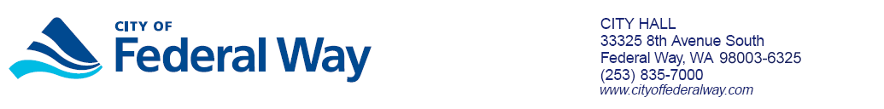

APPLICATION FOR REDUCED CABLE TV RATE

Cable TV discounts are available for Federal Way low income senior or disabled citizens with existing Comcast cable accounts. Qualifying citizens are eligible for 30% discount on limited cable service rate.

To apply please complete this form and return to the City of Federal Way.

(Comcast cable account holder information)

Name: ______________________________________

Address: ______________________________________

______________________________________

Phone: ______________________________________

Mailing ______________________________________
Address:
______________________________________

Please provide the following information for qualification:

Number residents in your household __________

Total household annual income $__________

2018 HUD MEDIAN INCOME GUIDELINES
# Household residents | Total Income | # Household residents | Total Income
1 | $37,450 annually | 5 | $57,800 annually
2 | $42,800 annually | 6 | $62,100 annually
3 | $48,150 annually | 7 | $66,350 annually
4 | $53,500 annually | 8 | $70,650 annually

And, (Comcast cable account holder information)

- ____ Senior Citizen (age 65 or older)
Date of birth: ______________ Age: ________
OR,
- ____ Disabled

Affidavit for Reduction in Cable TV Rates

I, (print your name) _________________________________, on oath, state that:

- The information on the application is true and correct to the best of my knowledge;

- I understand that I am eligible for a reduction in my cable services rate, so long as the information on the application is true, and that I must notify the City promptly if there is any change in my condition as described on this form; and

- I understand that in order for the City to determine my eligibility for a reduction in my cable service rate, the City may require additional information from me, which I must provide in order to receive or continue to receive this reduction; and

- I understand that if it is determined at any point in time that I am ineligible to receive a reduction in my cable service rate, I may be responsible for payment of any charges for the difference between the reduced and standard rates charged by the cable company.

_________________________________________
Applicant Signature

- PLEASE RETURN COMPLETED FORM TO:

CITY OF FEDERAL WAY
Cable Franchise Customer Services / IT
33325 8th Avenue South
FEDERAL WAY, WA 98003-6325

- For more information please call 253 835 2555

FOR OFFICIAL USE ONLY
Authorized Official Approving Application:

__________________________________________________________
Signature Date

_____________________________________________________________________
Cable Franchise Coordinator

