CITY OF FEDERAL WAY
REQUEST FOR PROPOSAL

- PURPOSE OF REQUEST.

The City of Federal Way (“City”) is requesting proposals for the purpose of securing a contractor to demolish the existing pool slide and interactive play structures at the Federal Way Community Center and replace and install new features that will fit within the existing footprint and meet local health department guidelines. The City’s needs are outlined in the following Request for Proposal (“RFP”).

- TIME SCHEDULE.

The City will follow the following timetable, which should result in a selection of a firm by February 1, 2019.

Issue RFP January 4, 2019
Deadline for Submittal of Proposals January 25, 2019
Preliminary Selection of Firm January 31, 2019
Notify Firm Chosen February 4, 2019

- INSTRUCTIONS TO PROPOSERS.

A. All proposals should be sent to:

Federal Way Community Center
Attn: Craig Feldman – Aquatics Coordinator
876 South 333rd St.
Federal Way, WA 98003
(253) 835-6932

- All proposals must be in a sealed envelope and clearly marked in the lower left-hand corner: “RFP” Pool Slide and play structure.

- All proposals must be received by January 25, 2019 at which time they will be opened. No faxed or telephone proposals will be accepted.

- Proposals should be prepared simply and economically, providing a straight forward, concise description of provider capabilities to satisfy the requirements of the request. Special bindings, colored displays, promotional materials, etc. are not desired. Emphasis should be on completeness and clarity of content. Use of recycled paper for requests and any printed or photocopied material created pursuant to a contract with the City is desirable whenever practicable. Use of both sides of paper sheets for any submittals to the City is desirable whenever practicable.

- The Aquatics Coordinator, Craig Feldman or representative, will notify the firm selected by February 4, 2019.

- All proposals must include the following information:

    - The names of individuals from those firms who will be working on the project and their areas of responsibility.

    - Specific experience of individuals relative to the proposed project.

    - A proposed outline of tasks, products and project schedule, including the number of hours required to complete each task or product.

    - A proposed budget based on the above outline of tasks, products and schedules.

    - References.

- SELECTION CRITERIA.

Factor Weight Given

- Responsiveness of the written proposal

to the purpose and scope of service. 30%

- Price. 40%

- Ability and history of successfully

completing contracts of this type,

meeting projected deadlines and

experience in similar work. 30%

Total Criteria Weight 100%

Each proposal will be independently evaluated on factors one through three.

- TERMS AND CONDITIONS.

- The City reserves the right to reject any and all proposals and to waive minor irregularities in any proposal.

- The City reserves the right to request clarification of information submitted and to request additional information from any proposer.

- The City reserves the right to award any contract to the next most qualified contractor if the successful contractor does not execute a contract within thirty (30) days after the award of the proposal.

- Any proposal may be withdrawn up until the date and time set above for opening of the proposals. Any proposal not so timely withdrawn shall constitute an irrevocable offer, for a period of ninety (90) days to sell to the City, the services described in the attached specifications, or until one or more of the proposals have been approved by the City administration, whichever occurs first.

- The contract resulting from acceptance of a proposal by the City shall be in a form supplied or approved by the City, and shall reflect the specifications in this RFP. A copy of the contract is available for review and shall include requirements to comply with ADA, Civil Rights Act, and EEO requirements. The City reserves the right to reject any proposed agreement or contract that does not conform to the specifications contained in this RFP, and which is not approved by the City Attorney’s office.

- The Recipient, in accordance with Title VI of the Civil Rights Act of 1964, 78 Stat. 252, 42 U.S.C. 2000d to 2000d-4 and Title 49, Code of Federal Regulations, Department of Transportation, Subtitle A, Office of the Secretary, Part 21, Nondiscrimination in Federally-Assisted Programs of the Department of Transportation issued pursuant to such Act, hereby notifies all bidders that it will affirmatively ensure that in any contract entered into pursuant to this advertisement, disadvantaged business enterprises as defined at 49 CFR Part 26 will be afforded full opportunity to submit bids in response to this invitation and will not be discriminated against on the grounds of race, color, national origin, or sex in consideration for an award.

- The City shall not be responsible for any costs incurred by the firm in preparing, submitting or presenting its response to the RFP.

- SCOPE OF SERVICES.

The scope of services includes the design, supply, permitting and installation of a two story slide and interactive play structure. The scope also includes an alternative service to demolish the existing slide and play structure. The City may award a contract for the full scope of work including the demolition or the base scope without demolition.

Located within the Federal Way Community Center’s Leisure Pool is a two story slide, (see figure 1) and an interactive play structure, (see figure 2), that need to be replaced due to age and deterioration. Both were installed in December of 2006.

The slide support structure is made out of concrete which has failed and the goal for replacement is to move to a steel support structure that is more visually appealing and will last in an Aquatic environment.

The play structure fits into a small footprint and the goal is to install a unit that is modular with features that are interchangeable so that the experience for the patrons can be varied although this may not be possible due to the space constraints.

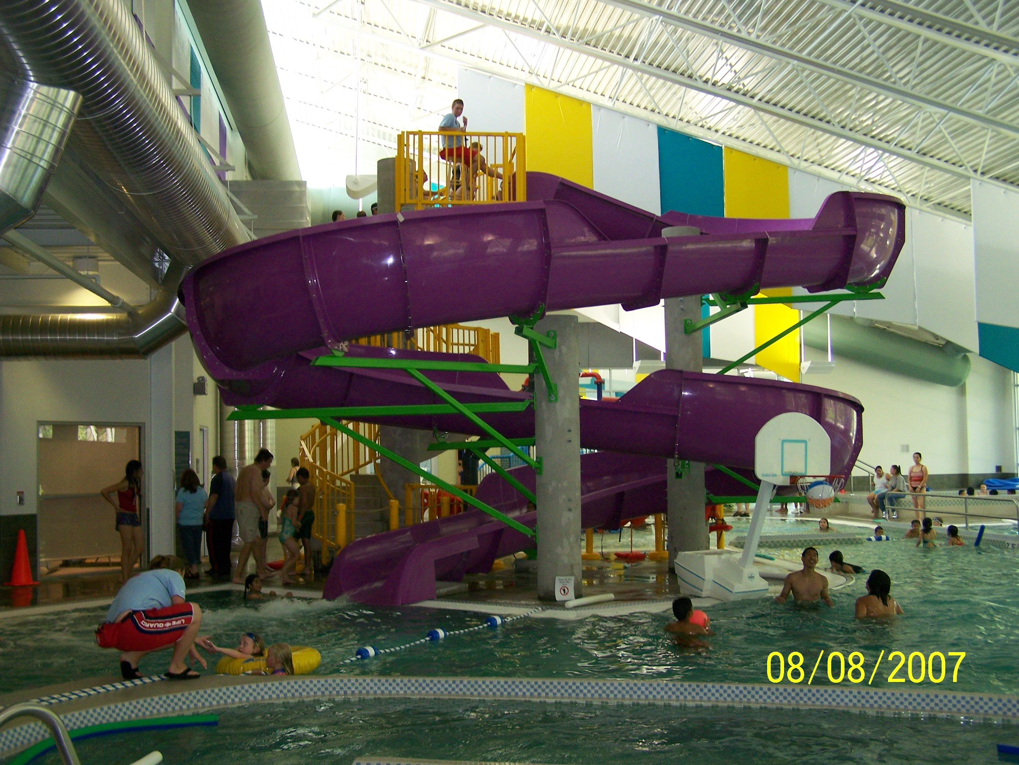

Figure 1

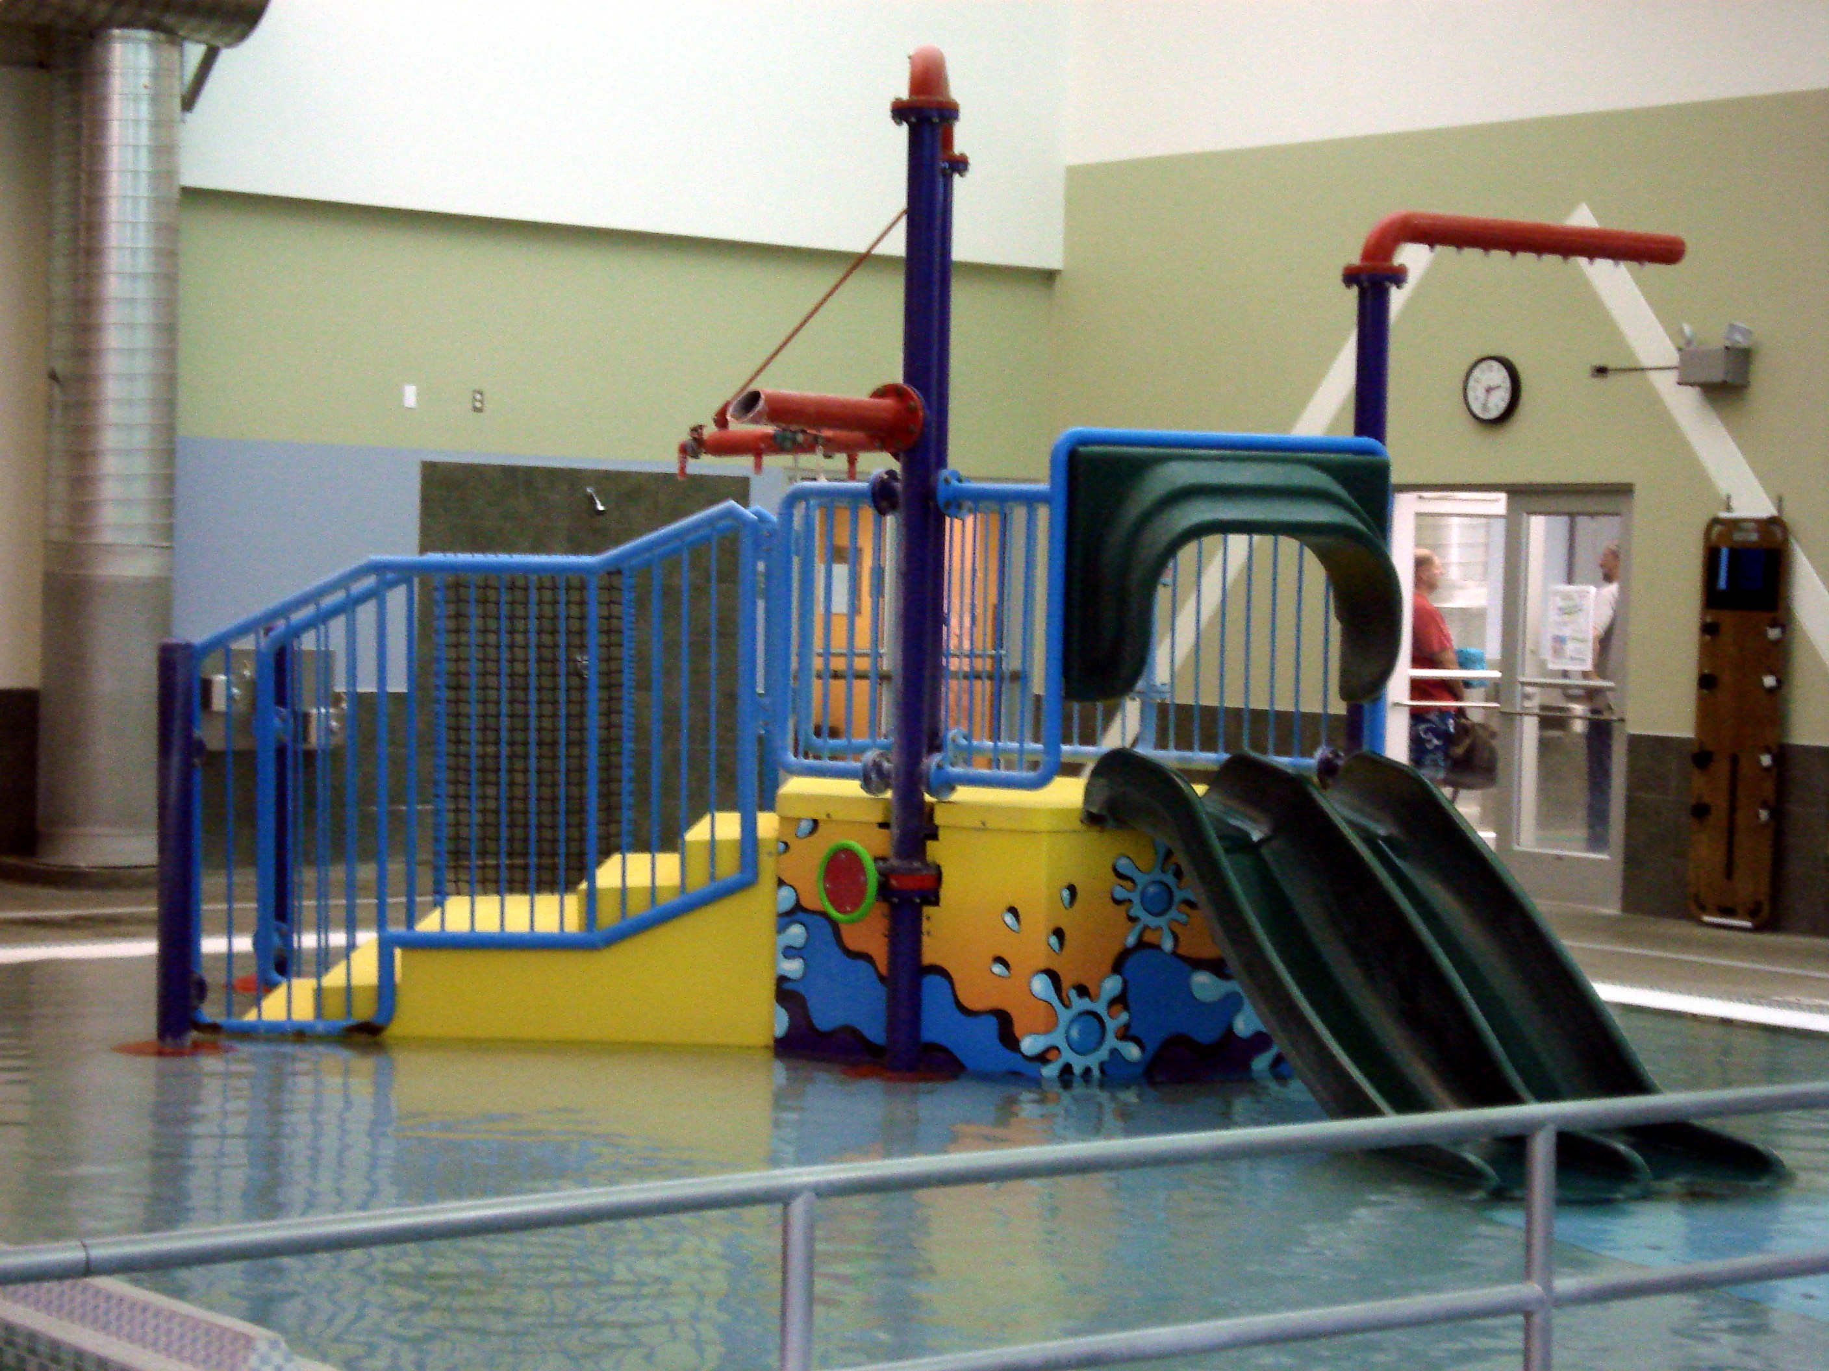

Figure 2

The Federal Way Community Center is looking to replace both of these features with attractions that will be more durable, will fit within the existing footprints, will be able to mate with existing water supply lines and will meet local health department guidelines. The project is tentatively scheduled for installation in the month of September 2019. Health Department permits must be obtained by the contractor and issued by the Health Department before the project begins.

The Proposals should include:

- Detailed description of the features.
- Sub-contractors the proposer intends to use and their scopes of work
- Timeline for project completion
- Warranty details

Present itemized prices for the following items:
- Demolition
- Delivery
- Permitting and installation
- All remaining scope, including design and supply of equipment

- COMPENSATION.

A. Please present detailed information on the firm’s proposed fee schedule for the specifications proposed and for any variation for non-routine services, inclusive of Washington state sales tax and any other applicable governmental charges. Please provide specifics as to definitions of routine versus non-routines tasks, what is fixed as opposed to variable, and how costs are adjusted according to that classification.

B. Payment by the City for the services will only be made after the services have been performed, an itemized billing statement is submitted in the form specified by the City and approved by the appropriate City representative, which shall specifically set forth the services performed, the name of the person performing such services, and the hourly labor charge rate for such person. Payment shall be made on a monthly basis, thirty (30) days after receipt of such billing statement.

- PUBLICATION.

Name of Publication: Date:
Federal Way Mirror January 4, 2019
City of Federal Way website January 4, 2019 thru
www.cityoffederalway.com/bids January 25, 2019

This bid will be emailed directly to vendors who provide this product and who service the Federal Way, WA area.

